Authored By: Mark Glassett

TABLE OF CONTENTS Page
1. ABSTRACT 1
2. OBJECTIVE 1
3. RESULTS 2
4. DISCUSSION 2
5. CONCLUSIONS 4
6. RECOMMENDATIONS 4

ABSTRACT
Zip Pen samples with design improvement to the PCB, Overmold and Carriage were tested for fluid ingress required for compliance to IEC 60601-2-2: 2009 clause 201.11.6.5.b). The improved design Zip Pen samples passed the requirements of the standard for this test.

OBJECTIVE
The objective of this test report is to document that the Zip Pen complies with IEC 60601-2-2: 2009 clause 201.11.6.5.b) requirements for fluid ingress after modifications were made to improve the design. The testing was performed per protocol XENG-PRT-439.

RESULTS

Continuity
Forty samples of EO Sterile and forty samples of gamma sterile Zip Pen were tested for continuity prior to the fluid ingress test per protocol XENG-PRT-439. The requirement is that a sample is considered out of tolerance if the resistance is greater than 50 ohms when the button is depressed or less than 10,000 ohms when the button is released. All 80 of the samples passed.

Note that 30 samples of non-sterile Zip Pen of the non-modified design were also tested for continuity and passed the test.

Fluid Ingress
Forty samples of EO Sterile and forty samples of gamma sterile Zip Pen were tested for fluid ingress per protocol XENG-PRT-439. The method written in this protocol is taken from IEC 60601-2-2:2009 clause 201.11.6.5.b). All 80 of the samples passed.

The 30 samples of non-sterile Zip Pen without design modifications were tested. There were four failures for fluid ingress in this sample group. See discussion below for the reason these were included in the test.

DISCUSSION
The samples used for verification were 40 each of catalog 2525-10 Zip Pen Lot #S170291sterilized with EO gas at Nelson labs and 40 each of catalog 2525-10 Lot #S170291 sterilized with gamma irradiation which is the standard method. The sterilization is documented in appendix III. The non-sterile product that was tested was catalog 2525-10BN Lot #S170100.

Prior to testing, all samples were subjected to temperature and humidity extremes and ship cycle testing per the protocol, this treatment is documented in appendix II. The improvements made to the product are documented on the following drawings:

X6020190-01 Rev 007A Zip Pen Sub Assembly
X5800103-01 Rev 003C Overmold, PCB, Zip Pen
X5800096-01 Rev 003B Carriage, Zip Pen
X4010337-01 Rev C PCB Detail, Zip

The protocol required a sample size of 68 units. The samples tested consisted of 40 EO sterile and 40 gamma sterile to achieve and exceed the 68 required by the protocol. The testing of the non-sterile product without the design improvements was included to show that the sterilization method does not contribute to the failure mode. Thirty of these were tested. This justifies the testing of a combined sample set of EO and gamma sterile samples.

Continuity
Eighty of the improved Zip Pen referenced above were tested for continuity prior to the ingress testing to insure that they were functioning correctly. The 80 samples met the requirements for continuity of less than 50 ohms when the button is depressed and greater than 10,000 ohms when no button is depressed. Thirty of the non-improved and non-sterile samples were also tested and passed this test. Documentation of this testing is shown in Appendix I. Summary statistics are as follows:

 | EO  Cut | EO Coag | Gamma Cut | Gamma Coag | Non Sterile Cut | Non Sterile Coag
Minimum | 1.2 | 1.2 | 1.2 | 1.2 | 1.2 | 1.3
Maximum | 2.9 | 1.9 | 3.8 | 1.9 | 3.4 | 2.0
Average | 1.58 | 1.44 | 1.60 | 1.40 | 1.58 | 1.52

Fluid Ingress
The 80 improved Zip Pen samples referenced above were tested for fluid ingress per protocol XENG-PRT-439 and passed the test. The method written in the protocol is taken from IEC 60601-2-2 clause 201.11.6.5.b). This test requires the Zip Pen to be held horizontally while 1 liter of saline solution is poured over the unit in 15 seconds with the switch activating parts uppermost. A voltage is applied to the switching circuit during the saline application. After the saline is applied, each switching circuit is activated 10 times. The a.c. impedance of the open switching circuits shall remain greater than 2,000 ohms during the test. All 80 of the samples passed. Documentation of this test is shown in Appendix I.

The 30 non-sterile sample that were not the improved design were tested with the same procedure. Four of the 30 samples failed the test. This was done to demonstrate that the failure mode is not dependent on the method of sterilization. Since the failure occurs in non-sterile assemblies, combining the EO and gamma parts to meet the sample size required by the protocol is justified.

CONCLUSIONS
This testing demonstrates that the improved design of the Zip Pen complies with the required standards that are referenced in the protocol.

RECOMMENDATIONS
This testing was performed to demonstrate compliance of the Zip Pen to IEC 6060 1-2-2: 2009 clause 201.11.6.5.b) after design improvements were made. It is recommended that the improved design be implemented at the supplier. The drawings for that implementation will be processed on DCO with this test report.

APPENDIX I
Test data

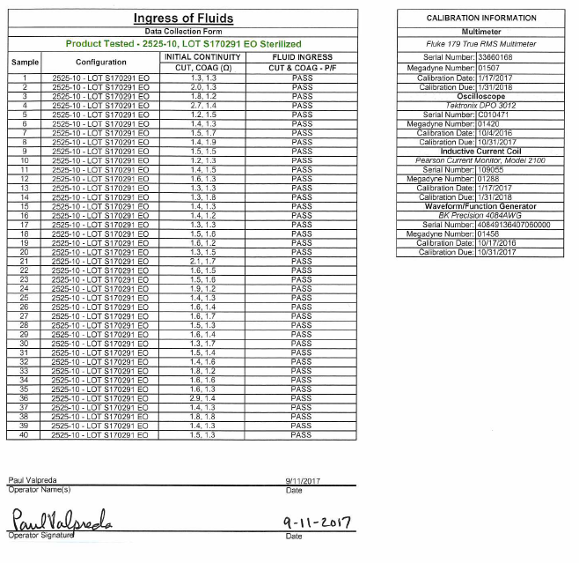

APPENDIX I (continued)
Test data

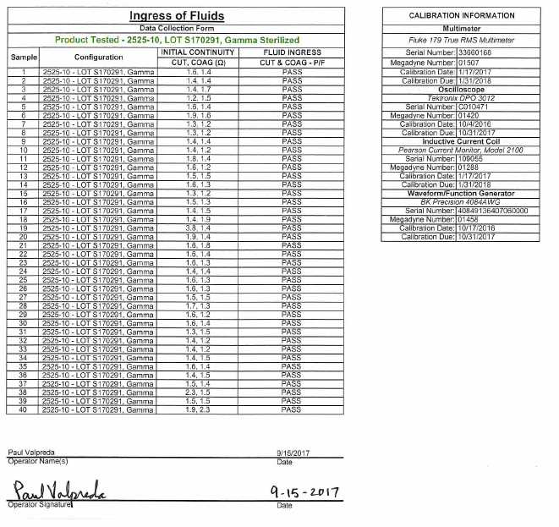
APPENDIX I (continued)
Test data

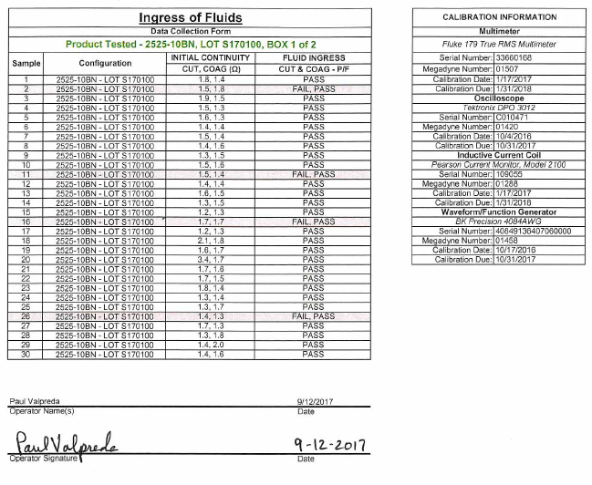

APPENDIX II
Pre-test Conditioning

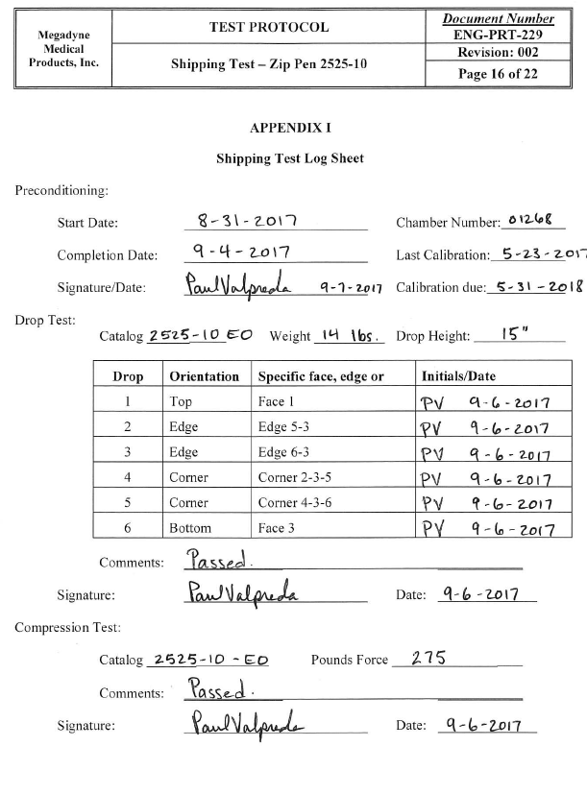
APPENDIX II (Continued)
Pre-test Conditioning

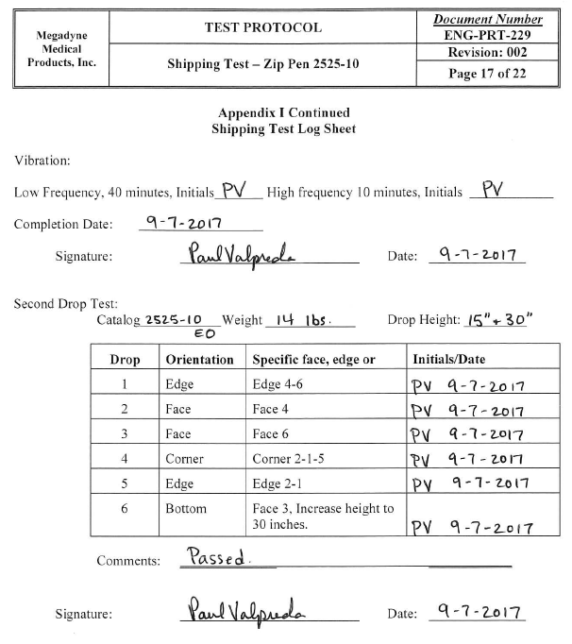
APPENDIX II (Continued)
Pre-test Conditioning

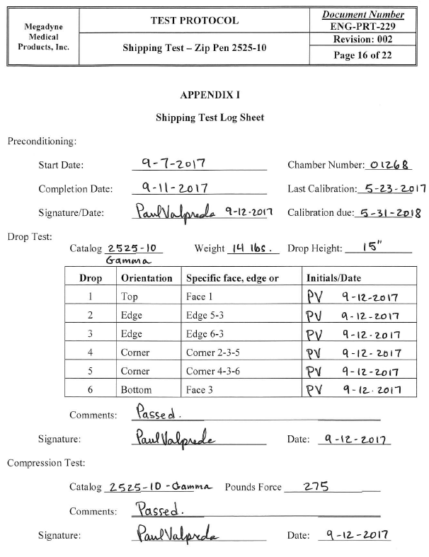
APPENDIX II (Continued)
Pre-test Conditioning

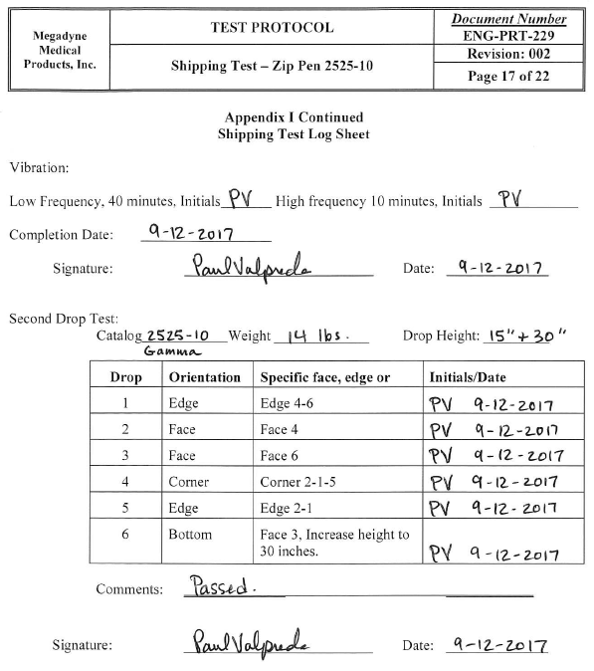
APPENDIX II (Continued)
Pre-test Conditioning

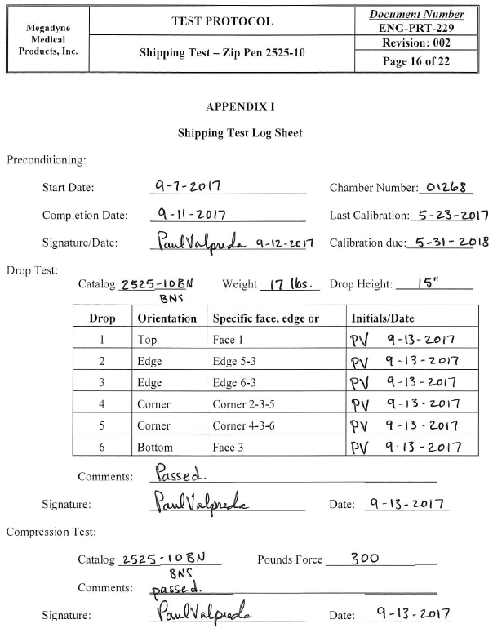
APPENDIX II (Continued)
Pre-test Conditioning

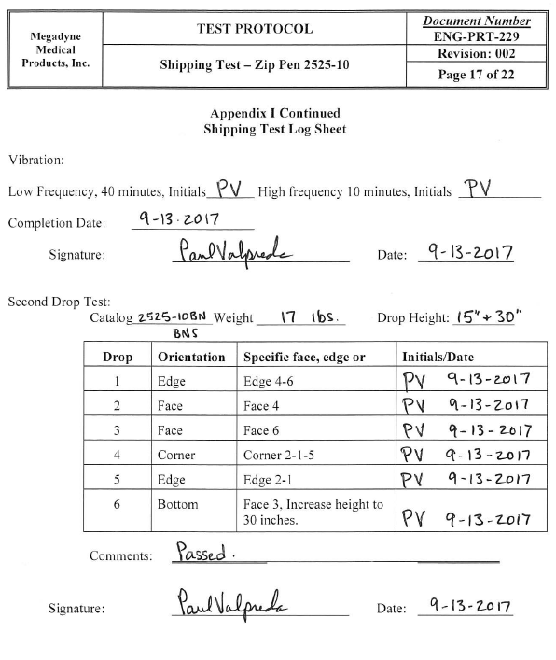
APPENDIX III
Sterilization Certificates

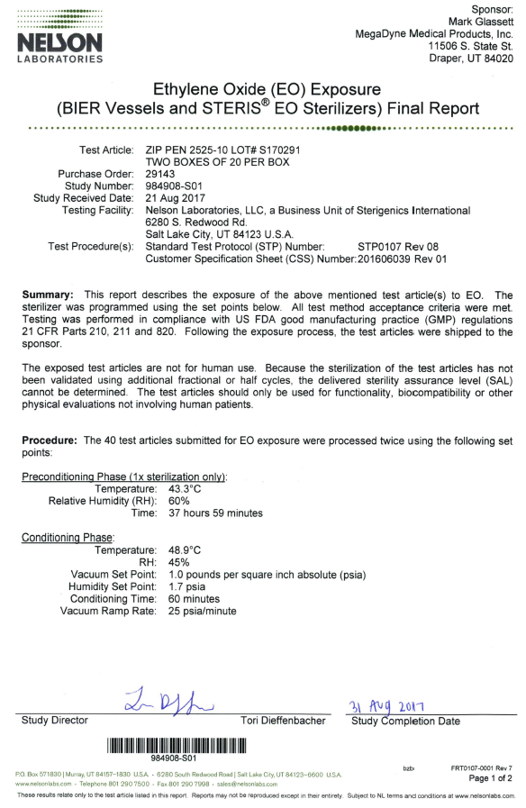
APPENDIX III (Continued)
Sterilization Certificates

